1. **Print even n odd num**

**Using if**

num=int(input("enter a number" ))  
if((num%2)==0):  
 print("even number",num)  
else:  
 print("odd number" ,num)

**Using for with if (prints num from 1 to n)**

num=int(input("enter a number"))   
for num in range(1,num+1):  
 if(num%2==0): if(num%2!=0  
 print(“even numbr” , num) print(“odd num” , num)

**Using for**

num=int(input("enter a number"))  
for num in range(2,num+1,2): for num in range(1,num+1,2):

print("even num" ,num)

**Using while**

num=int(input("enter a number"))  
n=1  
while n<=num:  
 if(n%2==0): if(n%2 !=0)  
 print(n)  
 n=n+1

1. **print the numbers in reverse order**

num=int(input("Enter a number to reverse"))  
rev_num=0  
while num!=0:  
 digit=num%10  
 rev_num=rev_num *10 + digit  
 num=num//10  
print("reversed num is" , rev_num)

1. **find the sum of (1,10) numbers using range and loops**

num=int(input("enter a num"))  
sum=0  
for i in range(1,num+1):  
 sum=sum+i  
print("sum is ", sum)

**Out put:-**

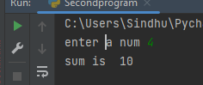

1. **find the factorial of given number**

num=int(input("enter num:"))  
fact=1  
for i in range(1,num+1):  
 fact=fact*i  
print("Factorial of %d is : %d" %(num,fact))

**Output:-**

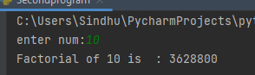

1. **find the factors of given number**

num=int(input("enter a num:"))  
for i in range(1,num+1):  
 if(num%i)==0:  
 print(i)

**Output:-**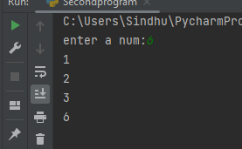

**6) x=[10,1,2,3,100]-> swap the frst and last ele in x o/p :[100,1,2,3,10](loops not required)**

x=[10,1,2,3,100]  
x[0],x[len(x)-1]=x[len(x)-1],x[0]  
print(x)

**Output:-**

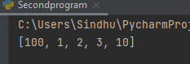

**7) x=[1,2,10,3,20,4] -> find the sum of even numbers and odd numbers**